**UNIT 4**

**VOCABULARY AND SPEAKING**

**LEASURE ACTIVITIES** (Aktivnosti u slobodno vreme)

Page (strana) 30, exercise (vežba) 1.

*Match (povežite) the words and photos*.

Answers (odgovori):

i – playing football

p – dancing

b- skiing

o- watching TV

f – going to the gym

g- taking photographs

c- cooking

d- playing computer games

l- sailing

j – listening to music

h- swimming

k- reading

n- eating in restaurants

e- going to the cinema

a - going running

m- sunbathing

**2** What do you like doing in your free time?

What does your friend /brother /sister like doing?

Do you like spending time (provoditi vreme) with friends?

What are the things you don’t like doing?



Answers: 2 taking, 3 like, 4 going, 5 sunbathing, 6 go

READING AND LISTENING

*My favourite season (Moje omiljeno godišnje doba)*

The four seasons are: Spring, Summer, Autumn (Am. Fall), Winter

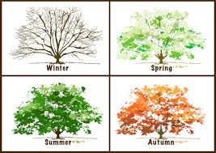

Read and listen to the texts on p. 33, then answer the questions in exercise 4 on page 32.

(Pročitajte i poslušajte tekstove na strani 33, a zatim odgovorite na pitanja u vežbi 4 na strani 32). Odgovori se nalaze ispod liste novih reči.

You can find the answers below the vocabulary list.

VOCABULARY LIST:

Favourite - omiljen

Cousin- brat /sestra od tetke, strica, ujaka

Funny – smešno

Warm – toplo

Sunny – sunčano

Wet – vlažno

Hot – vrelo

Rainy- kišovito

Flower – cvet

Joke – šala

Winter is nine months long – Zima traje 9 meseci.

It isn’t true.- To nije tačno.

To go down a mountain – spuštati se niz planinu

Fast – brzo

Amazing- divno, izvanredno

Answers to exercise 4

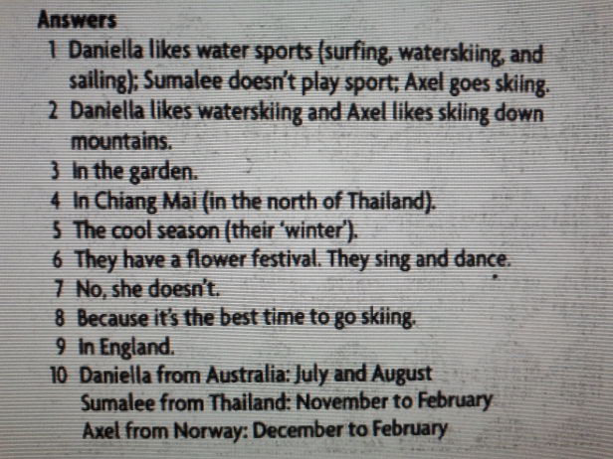

Write an e-mail to a pen friend. Start with *Dear* ... and end with *Love* or *Best wishes.*

These are the questions to help you:

1. Where do you live?
2. How many seasons are there in your country?
3. What do you like doing in different seasons?
4. What is your favourite seasons and why?