27 April 2020

UNIT 6: ENTERTAINING

1. Why is entertaining a business partner important?
2. Imagine you have to entertain a group of foreign business people. Where would you take them?

(You will find some of the possible answers at the end of this document).

1. You have to take businesspeople out for lunch (also: power lunch) or dinner. Look at exercise Vocabulary A, p. 52. First try to match the adjectives with the nouns, then think how each factor is important.
2. Do exercise B and C on page 53..

Words you may not know:

Crab – kraba, račić

Duck- patka

Lobster- jastog

Prawns/shrimps – škampi

Salmon - losos

Veal- teletina

Venison – srnetina

Poultry- živina

Bottled – u flaši

Draught – točen

Sparkling – penušav, gaziran

Still- negaziran

Tap – iz česme

Vintage- kvalitetan (of high quality and was made in a particular year and can be kept for several years in order to improve it)

House - provided by a restaurant to be drunk with meals

You can also check other food names below.

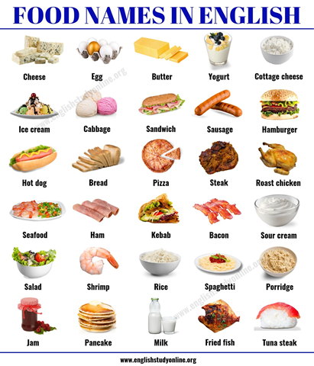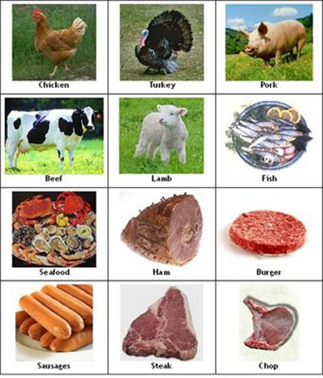

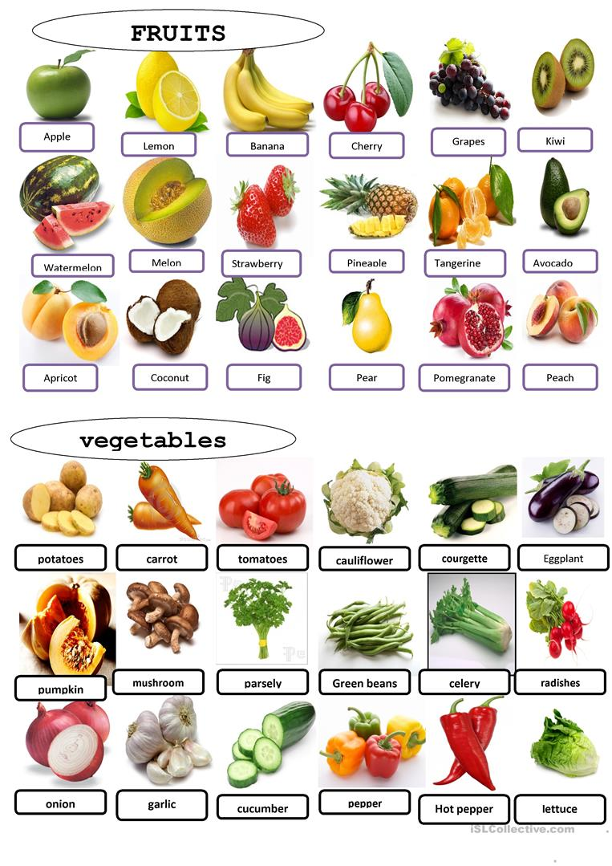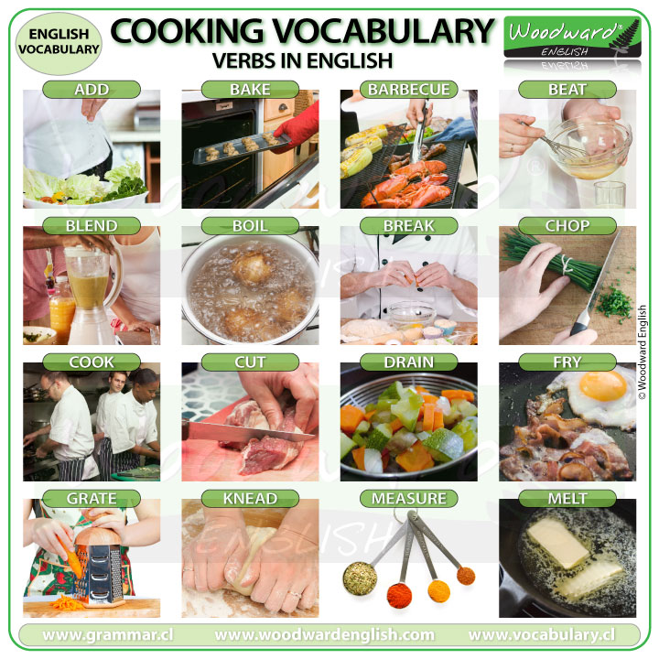

**TASK:**

Do exercise D on page 53 describing a dish from our country. Please, email your work.

Vocabulary:

Dish – jelo

Spicy- začinjeno

Hot – ljuto

Bitter – kiselo

Side dish- prilog uz glavno jelo

**ANSWERS:**

1. Entertaining is a way to size up (look at and make a judgement about sb) a potential business partner and establish a relationship.

2. I would take them to a restaurant, a café, a museum, a gallery, theatre, cinema, Petrovaradin fortress, Sremski Karlovci (for wine tasting), Štrand, one of the Fruška gora monasteries , a football match, shopping.

3.



- A cosy atmosphere allows you to relax and have a friendly/pleasant conversation and build a rapport.

An exciting atmosphere helps you relax and have fun.

- Offering your guests local food is a way for your guest(s) to discover something new and learn about the culture.

- When choosing the location you could consult your guest(s). They (she/he) might be tired and prefer somewhere close to their hotel.

- Spending money too much money can be seen as showing off. On the other hand, some guests can see it as a sign of respect or that your company is going strong.

- Efficient service in a restaurant/café enables you to have a pleasant time with your guest and makes him feel welcome.

B:

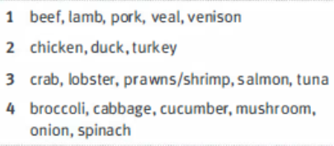

C:

