21 May 2020
UNIT 8 – A DATE TO REMEMBER
STARTER
What are the Past Simple of these verbs: eat, drink, drive, fly, listen, make, ride, take, watch wear?
You will find the list of IRREGULAR VERBS on page 158!
You will find the correct answers at the end of this file.
First match the verbs with the photos on pages 60 and 61.
Now try to make a question for each photo (Task 2 , page 61). For example:
Did people watch television a hundred years ago? (.. pre sto godina) – Yes, I think they did. /No, they didn’t/ I’m not sure.
Ago = pre
Npr. I saw her two days ago – Video/Videla sam je pre dva dana.
A week ago – pre nedelju dana
A month ago – pre mesec dana
A year ago – pre godinu dana
Three years ago – pre tri godine
Half an hour ago – pre prola sata
Ten minutes ago – pre deset minuta
An hour ago – pre sat vremena

See if you know the year each item in the photo was invented in. (to invent – izumeti)
Ride a bike – voziti bicikl
To wear jeans – nositi farmerice

For example: A television was invented in .....
You will find the correct answers below.

Do Grammar Spot on page 61.
Go on to the next task Time expressions 1.
Ask questions (Task 2 on page 61) and give answers that are true for you.
To arrive – stići
Term – semestar
Last – poslednji put
A break – pauza

LISTENING
Go to page 63.
Do Exercise 1.
VOCABULARY:
Get married – venčati se
Go out – zabavljati se
Fall in love – zaljubiti se
Get engaged- veriti se
Get divorced – razvesti se

Do Task 2 on page 63, then listen to the Track 8.4
Listen to the recording twice, then answer the questions in Task 4, page 63.
Finally, do Task 5.

VOCABULARY:
Good-looking= zgodan, lep
Girlfriend- devojka
Beautiful – lep
To cry- plakati
To go to college – krenuti na fakultet, studirati
Boyfriend – momak
To have a party – napraviti žur
To invite somebody – pozvati nekoga
A lake – jezero
No way! – Nema šanse!
Peace – mir
Finally – konačno
Surprised – iznenađen
Wonderful – divan
To have a great time – odlično se provesti
Wedding – venčanje
Fall (AmE)- autumn

WRITTEN TASK:
Write 10 sentencis saying what you did yesterday .
Use can use some of the following with suitable time expressions: get up, have a shower, wash my face, brush my teeth, have breakfast, leave home, drive/walk to school/work, take a bus to town/work, do the shopping, go out, meet friends, have lunch, cook lunch, make some coffee, invite some friends, watch TV, listen to music, go for a walk in the park/along the river, ride a bike, run in the park, sit in a cafe for a while, go to the cinema/theatre, read a book, go to bed, etc.

Please, email your work.

CORRECT ANSWERS:

Past Simple forms: ate, drank, drove, flew, listened, made, rode, took, watched, wore

Matching verbs with the photos:
- Watch television
- Drink Coca-Cola
- Make phone calls
- Drive cars
- Listen to records
- Eat hamburgers
- Take photos
- Fly planes
- Ride bikes
- Wear jeans

Inventions:

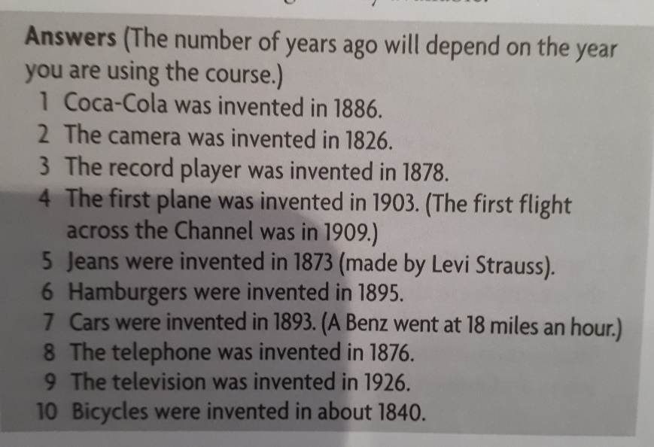

GRAMMAR SPOT:
He lived in London.
Did you live in London?
Did she live in London?
I didn’t live in London.
He didn’t live in London.

TIME EXPRESSIONS:

At seven o’clock
On Saturday
At night
In 2002
In summer
In the morning
On Sunday evening
In September
At weekends
In the nineteenth century

TASK 2, PAGE 61 When did….?
- When did you get up?- I got up at….,….hours ago
- When did you have breakfast? – I had breakfast…
- When did you arrive at school?- I arrived at school at…..
- When did you start learning English? – I started learning English in ….., ….. years ago.
- When did you start at this school?- I started at this school in…., three years ago
- When did this term start? – It started in February, almost four months ago
- When did you last use a computer?- I last used a computer ….. ago
- When did you learn to ride a bike? – I learned /learnt to ride a bike…
- When did your parents get married? - They got married in …., …. years ago.
- When did you last have a coffee break? – I last had a coffee break ….

LISTENING, TASK 4 , PAGE 63
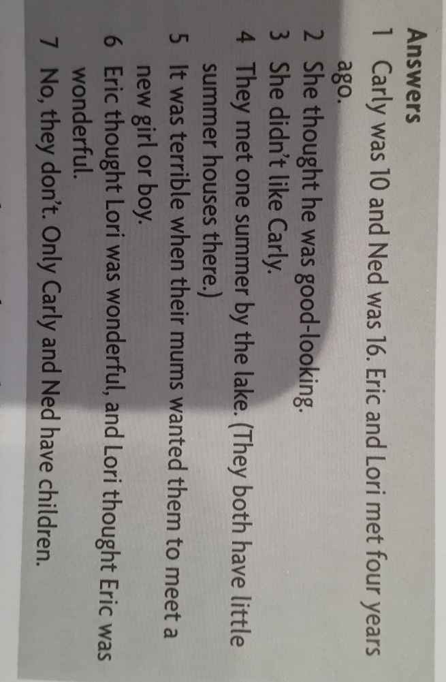

LISTENING, TASK 5, PAGE 63

