14 May 2020
UNIT 7
READING
Look at task 1 on page 56 and try to find the translation for the given nouns, verbs and adjectives.
You can check your answers below.
Read the two texts on page 57, then do task 4, p 56. You can check your answers below.
Compare Amelia with Yuri (task 5, p.56).
Finally, complete the questions in task 6 and answer the questions

WRITTEN TASK:
Write a shot text (up to 10 sentences) about a famous person from history and email your work.

CORRECT ANSWERS:
Airshow- aeromiting
Fighter jet = avion-lovac
Fight- bitka, borba
Experiences – doživljaji
Satellite- satelit
Break a record- oboriti rekord
Travel- putovati
Disappear – nestati
Join the club– postati član kluba
Survive- preživeti
Crash- srušiti se (His plane crashed)
Excellent – odličan
Dangerous – opasan
Secret- tajan

ALSO:
Rich – bogat
Hospital - bolnica
dangerous – opasan
alone- sam
nearly – skoro
poor – siromašan
space- vasiona, svemir

NOTE:
To study nursing – obučavati se za medicinsku sestru
Flying lessons- časovi letenja
To travel around the world – putovati po svetu
At the end of something – na kraju nečega
To study hard- vredno je učio
A natural pilot – stvoren za pilota
Air force – vojno vazduhoplovstvo
Be the best in all the tests- biti najbolji na svim testovima

Task 4, p 56
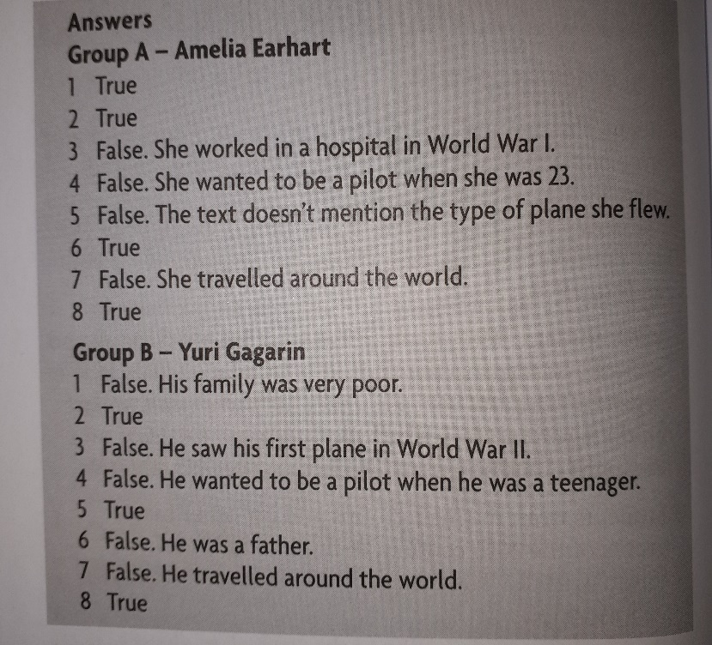
Task 5, p. 56.
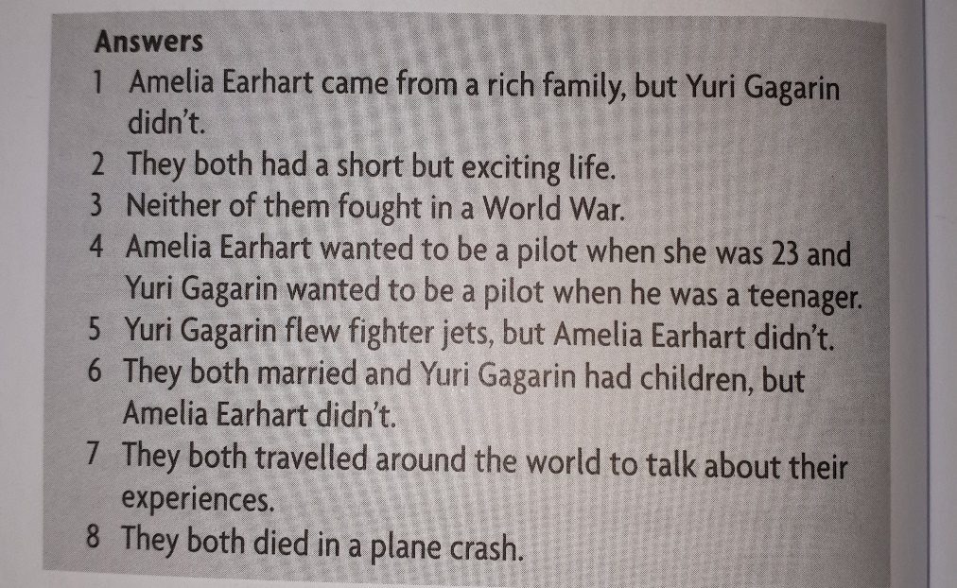
Task 6, p.56
QUESTIONS:

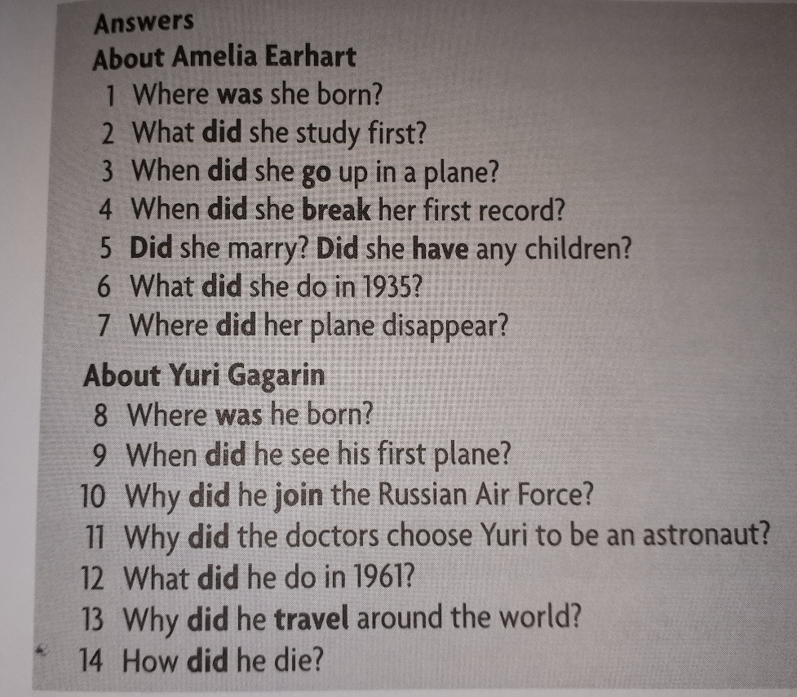

Task 6, p. 56
ANSWERS:
